From: http://circa.com/politics/accountability/nsa-unmasking-congress-notified-as-often-as-once-a-month

US spy agencies intercept and unmask congressional figures as often as once a monthby John Solomon and Sara Carter
Accountability
April 6, 2017
WATCH | National security reporter Sara Carter reports that US spy agencies intercept and unmask congressional figures as often as once a month.
1 of 30
The U.S. government’s foreign surveillance sweeps up American lawmakers and their staffers so routinely now that Congress is alerted as often as once a month that its employees involved in intercepted conversations have been unmasked and their identities shared with intelligence or law enforcement agencies, Circa has learned.
2 of 30
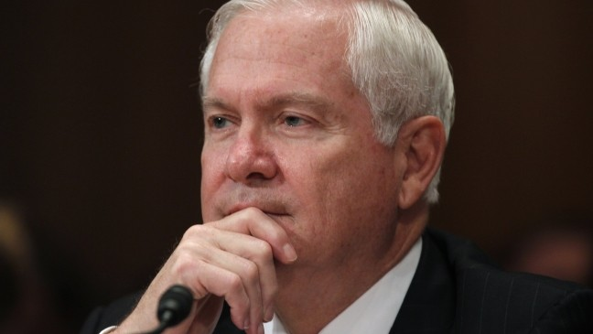
The so-called Gates notifications -- named for former CIA Director Robert Gates -- go to the Gang of Eight leadership team in Congress.
3 of 30
The Gang of Eight includes the House speaker and minority leader, the Senate Republican and Democratic leaders and the bipartisan heads of both chambers' intelligence committees.
Often though, the affected lawmakers or congressional aides aren’t told about the unmasking, unless it involves a security or hacking threat. So some affected lawmakers may not know about their appearance in unredacted executive branch intelligence reports, according to intelligence community sources, who spoke only on condition of anonymity.
4 of 30
The notifications are just one of many growing signs that what once was considered a rare event inside the intelligence community -- the unmasking of a conversation involving Americans captured
- overseas by the National Security Agency or
- the FBI under the Foreign Intelligence Surveillance Act
-- is now becoming more widespread after President Obama lowered the thresholds and privacy protections for such sharing starting in 2011.
The NSA is authorized to spy on foreign powers without a court warrant under Section 702 of the FISA law.
5 of 30
But the agency is legally prohibited from targeting Americans when spying overseas.
And
- when an American is accidentally intercepted talking to the agent of a foreign power or
- when two foreigners are captured talking about an American,
NSA is supposed to protect that U.S. person's privacy by redacting the identity. Such intercepts are known as incidental collections and the redactions are known as minimization.
But over the last decade, spy agencies have gotten more latitude to unmask and share American identities.
6 of 30
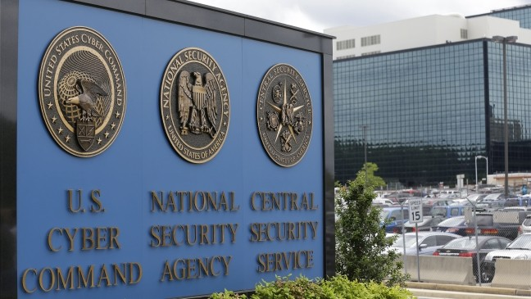
Intelligence community professionals insist that they follow strict rules to ensure that any unmaskings are warranted for national security reasons.
7 of 30
They say the notifications to Congress must be viewed in the context that the NSA and FBI are monitoring countless foreign threats each day.
The unmasking of an American who was intercepted communicating with a foreign power overseas or mentioned in the conversations of two intercepted foreigners generally can only occur if there is an imminent security or criminal threat -- a relatively high threshold -- or if the unredacting of the identity makes it easier for intelligence officials to understand foreign intelligence, a much lower threshold.
8 of 30
There are hints in those strict rules of what other types of Americans beyond Congress might occasionally be unmasked.
The FBI wrote rules with the Obama administration in 2015 that actually conceive of circumstances and protections in which its FISA intercepts could be unmasked or shared for Americans in other sensitive professions where First Amendment privileges are assumed, including journalists, clergy, lawyers and doctors.
9 of 30
Such intercepts have a special designation as “sensitive information” in the new rules but can be distributed electronically to other agencies “if it is first determined that such information reasonably appears to be foreign intelligence information, necessary to understand foreign intelligence information or assess or importance of it, or is evidence of a crime.”
"Something is wrong if Congress and other Americans are routinely being unmasked.."
—Sen. Charles Grassley, R-Iowa
10 of 30
The ease at which closely held intercepts could now be shared was put on full display after Circa reported last week that Obama’s rule changes made it easier for political aides like his national security adviser Susan Rice to access intercepts between July and January mentioning the names of Donald Trump campaign and transition associates.
11 of 30
Rice admitted Tuesday that she did request and consume unmasked intelligence reports of Trump figures, but said her interests weren’t political, though she did not specify the national security concern that drove her to consume spy work that incidentally captured data about the incoming administration. She insisted what she did was legal and that she never leaked any intelligence information.
Congress is expected to call her to testify later this spring in the burgeoning Russia election hacking and intelligence scandal gripping Washington.
12 of 30
President Trump said Wednesday, however, he thinks what Rice did may have violated laws designed to protect the privacy of Americans from unnecessary spying.
The NSA and FBI do not release any public information about when or how often they intercept conversations involving Americans, lawmakers, clergy, lawyers or journalists and why they are sometimes unmasked.
13 of 30
Three years ago, Senate Judiciary Committee Chairman Charles Grassley (R-IA) was alerted that a government whistleblower’s communication with his staff was somehow obtained by the intelligence community, according to public reports at the time. About the same time, the CIA was forced to admit its employees spied into the computers used by Democratic staffers of the Senate Intelligence Committee working for Sen. Dianne Feinstein (D-CA).
14 of 30
They are two rare public acknowledgements of the executive branch monitoring or spying on Congress. Grassley has never acknowledged the alleged intercept but instead requested that two notifications he received from the intelligence community’s watchdog about “whistleblower communications” be declassified. He got no response in three years.
He told Circa it may be time for lawmakers to demand more transparency about what the intelligence community is collecting on Congress and other Americans, how often it is occurring and why.
15 of 30
"While unmasking can be important to understand intelligence in very limited situations, something is wrong if Congress and other Americans are routinely being unmasked in surveillance reports that are supposed to be focused on foreign intelligence,” Grassley said. “Separation of powers and accountability for the intelligence community are vital to protect civil liberties and ensure public support for the intelligence gathering authorities needed to protect national security.
16 of 30
“Americans need to be able to trust that these national security tools aren’t being abused for political purposes," Grassley said. "Illegal leaks of classified information including information revealing the identity of Americans in intelligence reports are wrong and dangerous and more likely to happen when safeguards are weakened as they were during the Obama administration.”
17 of 30
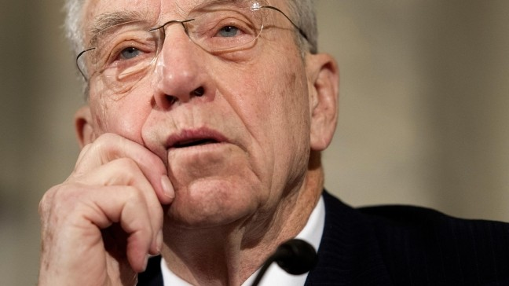
Grassley’s concerns are likely to be given considerable weight on Capitol Hill since his committee will be involved later this year in debating the renewal of the FISA law that gives the NSA and FBI their foreign surveillance powers.
18 of 30
Former Rep. Pete Hoekstra, who served on the House Intelligence Committee as chairman or ranking member during the end of George W. Bush administration and beginning of the Obama years, said it was rare during his tenure to be alerted that a lawmaker or congressional staffer had been unmasked unless there was s serious threat of espionage against the lawmaker.
"I am not surprised that they are intercepting (congressional) calls overseas with 535 members and their staff. What surprises me is that they are unmasking them.
19 of 30
"What is the foreign intelligence value of unmasking the members of Congress? It makes the intelligence community no different than the IRS under Lois Lerner. It's awful.," Hoekstra added. "If I were in Congress still this would be of significant concern that this unmasking has made its way to policymakers."
20 of 30
When the NSA was formed and empowered to spy on foreign powers without needing a court warrant under Section 702 of the FISA law, it was specifically prohibited from targeting Americans overseas. If a U.S. figure was accidentally intercepted, the data was supposed to be redacted from any intelligence reporting and the American’s identity replaced with a generic identifier like U.S. Citizen One. Unmasking the name was considered a rare event.
21 of 30
Likewise, FBI monitoring of foreign threats inside the U.S. under a court-ordered FISA warrant used to be closely held.
But starting under George W. Bush’s administration and continuing under Obama, the ability of both agencies to share intercepted information about Americans across a wider swath of government, including political appointees, has expanded.
22 of 30
That expanded access is the focus of a leak investigation into an FBI FISA intercept of Russian Ambassador Sergey Kislyak that incidentally captured soon-to-be Trump National Security Adviser Mike Flynn in December. The intercept was subsequently leaked to the media, but the FBI to date has been mum in public hearings about who it shared the intercept with and who might be the source of the leaks.
23 of 30
Intelligence community professionals long fought to get the rules relaxed, saying such changes improve intelligence sharing aimed at solving threats involving lone-wolf terrorism, hackers and foreign espionage that have become more complicated in the digital era.
Due to rules Obama got approved by the FISA review court in 2011 and adapted again in 2015 and just before he left office in January, almost anyone in the intelligence community can request unmasked information and get it if they can prove they need it to better understand raw intelligence.
24 of 30
That’s a low threshold, and even intelligence professionals who pressed for the loosening of the rules acknowledge that without careful safeguards such unmasking can be abused for political espionage or other non-security related reasons.
“Unmasking requests occur dozens if not hundreds of times a year,” an intelligence official said.
The NSA and FBI don’t publicly report how many times an intercepted American conversation is unmasked for anyone in the special circumstances categories.
25 of 30
If there are a dozen or so congressional figures unmasked a year, could there be similar numbers in other categories such as lawyers, lobbyists, clergy and reporters?
A senior intelligence source declined to answer questions about those categories but acknowledged the NSA “is collecting and storing so much real-time communication that it incidentally captures Americans of all walks of life. The question of unmasking then comes down to who is requesting and why they need it. Need to know can often be in the eye of the beholder.”
26 of 30
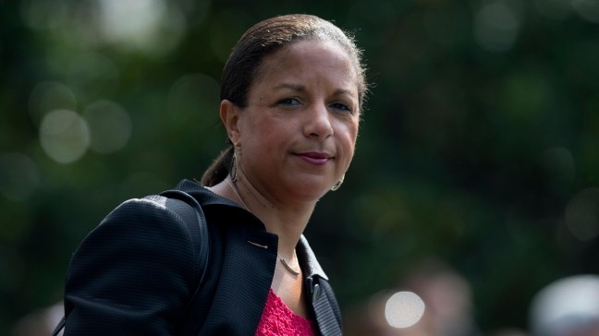
“Rice’s ability to consumed unmasked information on Trump figures shows the threshold sensitivities for political figures can be quite low,” added a second intelligence source.
27 of 30
The FBI is the only agency whose unmasking and intercepts rules specifically cite seven categories of special circumstances where First Amendment privileges of U.S. persons should be given extra weight. They include:
- religious activities such as those of clergy,
- academic activities such as educators,
- political activities such as Congress,
- U.S. media reporters,
- sexual or personal activities,
- medical of psychiatric activities and
- matters pertaining to minor children.
28 of 30
Intelligence agencies like NSA and CIA give similar regard to those categories even though they are not encoded in their publicly available intercept and unmasking rules, officials said.
But whistleblowers, whose legal right to go to Congress is protected by the law, are not covered by the special designations.

